Book 03 — Federal Application-Aware Networking — Certificates & Tokens: Cryptographic Identity
  - PKI as a Naming-Plane Function · ACME Lifecycle Automation · OAuth 2.0/OIDC · Phishing-Resistant MFA · Workload Identity
Federal Cloud Services
2026-07-06
Table of contents

INTERNAL — NOT FOR PUBLIC DISTRIBUTION
 Important
Series Context — This document is Part 3 of the 19-part Federal Application-Aware Networking series. Book 01 established the naming and addressing plane — authoritative DNS, DHCP, and IPAM as the landing-zone source of truth. Book 02 established device identity at the network port — 802.1X, EAP-TLS, and the machine certificate as the admission credential. This part completes the identity plane’s cryptographic foundation: how certificates are issued, revoked, and automated as a function of the naming plane, and how tokens replace network sessions as the carrier of identity. Books 07 and 08 — SQL Server authentication modernization — are direct applications of the doctrine this part establishes.

For decision makers: read this page first.
Your agency’s authentication architecture still assumes the network is a place. Kerberos — the protocol beneath most federal application sign-ins — proves identity by demonstrating a relationship to the network: a reachable domain controller, a continuous session, a stable path. The transport modernization your agency is executing (SD-WAN multipath, direct internet access under TIC 3.0, multi-cloud landing zones) removes every one of those assumptions on purpose, because removing them is what makes the network fast and resilient.
Four things this document establishes:
- You cannot keep both the modern network and the legacy credential. When session-based authentication fails on modern transport, it does not stop — it silently falls back to NTLM, a protocol that cannot be audited, cannot be gated by policy, and is replayable by attackers. Modernizing the WAN without modernizing the credential converts an unknown fraction of your authentication to your weakest protocol without anyone deciding to.
- Certificates are a naming-plane function, not a parallel bureaucracy. Which authorities may issue for your names is published and enforced in DNS (CAA records); automated issuance proves control of a name through DNS (ACME DNS-01); revocation checking resolves through DNS. The authoritative DDI platform built in Book 01 is the issuance gate. Certificate operations belong to the same functional plane.
- Manual certificate management is ending by arithmetic, not by preference. Industry policy is driving public certificate lifetimes from 398 days toward 47 days by 2029. At those lifetimes, a mid-size estate generates a renewal event faster than any ticket queue can process one. Automation is the only operating model that closes.
- Phishing-resistant MFA is PKI wearing a usability layer. The only credential families federal policy accepts as phishing-resistant — PIV certificates and FIDO2 authenticators — are hardware-held key pairs bound to names. The mandates of OMB M-22-09 and BOD 25-01 are implementable exactly to the degree that this document’s certificate and token architecture exists.
The controls this document closes — IA-5(2), SC-12, SC-17, IA-2(1), IA-2(2) — have no alternate closure path. Each claim is demonstrated against control text and protocol behavior in the closure table at the end.

1. What This Document Addresses
Every book in this series ultimately depends on one substitution: identity carried by the network path is replaced by identity carried in the credential. Book 01 built the authoritative naming plane. Book 02 used a machine certificate to authenticate devices at the port. This book explains where those certificates come from, why they must be automated, why tokens rather than sessions must carry user and workload identity, and which NIST SP 800-53 Rev 5 controls have no closure path that does not run through this architecture.
The argument proceeds in five movements:
- Why session-based, location-bound authentication died. Kerberos binds identity to a network session; SD-WAN active-active multipath structurally eliminates the stable session the ticket assumes. This is not a tuning problem — it is a protocol-versus-transport contradiction.
- PKI is a naming-plane function. Certificate issuance, revocation checking, and DNS are one substrate. CAA records put issuance policy in DNS; ACME DNS-01 challenges make the authoritative zone the issuance gate; CRL/OCSP reachability is a DNS resolution dependency.
- Certificate lifecycle automation. ACME, SCEP/EST, and short-lived certificates end the spreadsheet-tracked certificate authority — an operational model that industry lifetime policy has made arithmetically impossible to sustain.
- Token-based identity. OAuth 2.0/OIDC, certificate-based authentication, and phishing-resistant MFA — the BOD 25-01 and OMB M-22-09 alignment layer.
- Machine and workload identity. Service principals, managed identities, and workload identity federation — the elimination of stored secrets from the non-human identity estate.
 Note
Where this sits in the Functional Plane Model — Certificates and tokens are identity-plane truth. The policy enforcement plane (conditional access, ZTNA, SASE PEPs) consumes this truth; it does not create it. Per the series hierarchy rule: enforcement planes can be re-platformed or absorbed; truth planes can only be depended on. A conditional access policy evaluating a forged or stale identity assertion enforces the wrong answer very efficiently. This book is about making the assertion true.

 Note
What this document does not cover — Directory rationalization and the authorization data model (which attributes a token should assert) are Book 05’s Principle 1 territory; privileged session management built on these credentials is Book 10; the SIEM content that consumes identity telemetry is Book 13. This document is the credential layer those parts assume: where keys come from, how they are governed, and how identity travels once it no longer rides the network session.

2. The Death of Session-Based, Location-Bound Authentication

2.1 The Three Bindings Kerberos Makes
Kerberos (RFC 4120) was engineered for a network that no longer exists, and its engineering was excellent for that network. A client obtains a ticket from a Key Distribution Center, presents it to a service, and the service validates it — all across a flat LAN measured in single-digit milliseconds. To make that work, Kerberos binds identity three ways:
The three bindings of session-based authentication and their fate on modern transport
Binding | What Kerberos Assumes | What the Modern Transport Provides
Session binding | The authenticated exchange rides one stateful, continuous connection between client and service | SD-WAN active-active multipath distributes packets of a single conversation across multiple simultaneous physical paths; inline inspection, NAT, and re-encryption interrupt session state by design
Location binding | A domain controller is reachable within sub-5 ms round-trip; the client and the KDC share a network | Workloads span on-premises virtualization, two hyperscale government clouds, and an externally managed tenancy; the KDC is co-located with none of them
Time binding | Client and KDC clocks agree within five minutes | The only binding that survives — NTP disciplining is solvable everywhere
Two of the three bindings are broken by the very technologies the rest of this series requires. That is the structural point: the transport modernization mandated by TIC 3.0 and demonstrated in Book 05 is incompatible with the authentication model most federal application estates still run. You cannot keep both.

2.2 What Multipath Does to a Session-Bound Ticket
Book 05 develops this argument in full — the security-stacking history in which inline proxies, NAT tiers, and stacked firewalls broke Kerberos sessions across the 2010s, and the multipath analysis showing why SD-WAN finishes the job. The load-bearing facts, restated:
- Under active-passive failover, a Kerberos exchange that is mid-flight when a path fails times out over several seconds — the “logon takes 45 seconds” symptom field offices report.
- Under active-active multipath, packets of one conversation traverse multiple physical paths simultaneously by design. The overlay resequences them into one ordered stream, and a transport-layer path switch costs roughly 50 ms. The transport problem is solved.
- But the authentication contract is not. A protocol that binds its proof of identity to the continuity of a network session inherits every discontinuity the session suffers — every NAT rebind, every inline decrypt/re-encrypt, every stateful device that sees only half a flow. Token-based authentication survives all of these, because the proof travels in the credential, not in the connection.
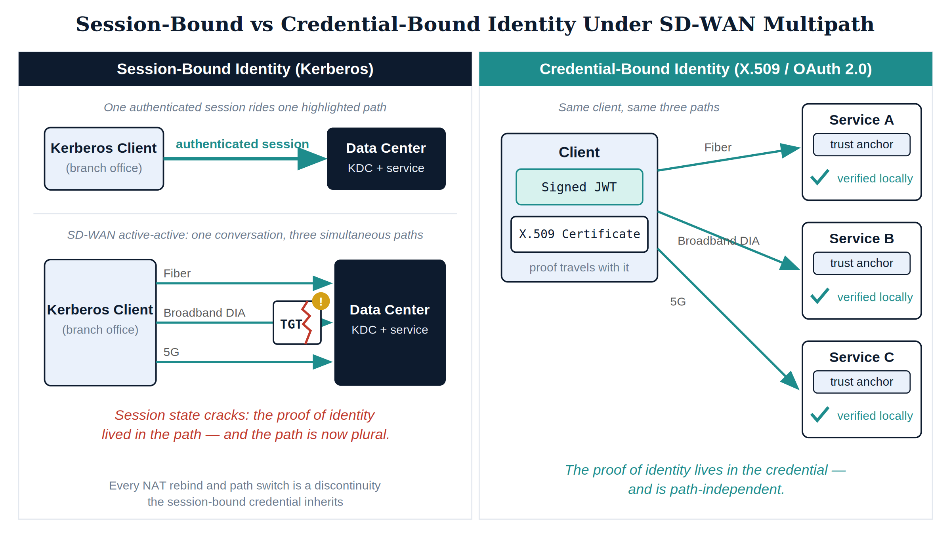
Figure 1: Session-bound versus credential-bound identity under SD-WAN multipath

2.3 The Fallback Nobody Chose
When Kerberos cannot complete — unreachable KDC, missing SPN, clock skew — Windows does not fail closed. It falls back to NTLM. Book 07 documents what that means for the database estate: authentication that cannot be audited at the token level, cannot be gated by conditional access, and is replayable via pass-the-hash. The fallback is silent, which means an agency that modernizes its WAN without modernizing its credential architecture does not keep Kerberos — it converts an unknown fraction of its authentication traffic to NTLM without anyone deciding to.
BOD 25-01’s secure configuration baselines and OMB M-22-09 both point the same direction: legacy authentication off, modern token-based authentication on, phishing-resistant MFA underneath it. The remainder of this book is the architecture that makes those directives implementable rather than aspirational.

2.4 The Property Table
The full comparison, stated as protocol properties rather than preferences — each row is checkable against protocol behavior, which is what the series’ consistency rules require of every claim:
Session-based versus credential-based identity as protocol properties
Property | Session-Based (Kerberos/NTLM) | Credential-Based (X.509 / OAuth 2.0 / OIDC)
Proof of identity lives in | The authenticated network session | The signed credential itself
Verification requires | Reachable KDC / domain controller callback | Local signature check against published trust anchors and keys
Survives path switch / NAT rebind | No — session state interrupted | Yes — nothing about validity references the path
Survives inline decrypt/re-encrypt | No — the middlebox is a session break | Yes — the assertion is opaque to the path
Works across boundaries the agency does not control | No — requires domain reachability | Yes — requires only the issuer’s published keys
Failure mode | Silent fallback to a weaker protocol (NTLM) | Explicit denial at the policy gate
Policy evaluation point | At initial ticket grant, then inert | At every issuance and every refresh-token redemption
Audit granularity | Logon events without cryptographic binding | Per-token, per-scope, per-device structured events
Latency dependency | Sub-5 ms round-trip assumption to the KDC | None beyond the request itself
The one-sentence version: the network stopped being a place, so identity can no longer be proof of place. Identity must be proof of key possession — a certificate or a token, verified by signature, valid anywhere the mathematics is valid, which is everywhere.

2.5 Why This Cannot Be Patched
Three remediation strategies are regularly proposed to keep session-based authentication alive on modern transport. Each fails for a structural reason, and naming the reason matters because the series’ Closure Necessity doctrine requires it:
- “Pin authentication traffic to a single path.” SD-WAN overlays can steer an application class onto one transport. But pinning authentication to a single path re-creates the active-passive failure mode for exactly the traffic least able to tolerate it, forfeits the multipath resilience the agency bought, and does nothing about the inline inspection and NAT that broke sessions before multipath existed. The remedy un-modernizes the WAN for the benefit of a 1999 protocol.
- “Deploy read-only domain controllers everywhere.” Replicating KDCs to every branch and cloud region restores the location binding by copying the location everywhere. It multiplies the credential estate’s attack surface (every KDC replica is a Tier-0 asset), does not fix session binding at all, and is impossible in environments the agency does not control — the externally managed tenancy has no domain controller and never will.
- “Extend the domain into the cloud.” Site-to-site tunnels carrying domain traffic to cloud regions recreate the hairpin that Book 05’s physics argument closed: authentication round-trips ride the tunnel back to wherever the domain controllers live, re-importing the latency floor into every logon. The tunnel moves the problem; it cannot shorten the distance.
Every patch preserves the premise — that identity is proven by network relationship — and the premise is what died. The remediation is not a better session; it is a credential that does not need one.

3. PKI as a Naming-Plane Function

3.1 A Certificate Is a Naming Claim
Strip the ceremony away and an X.509 certificate is one sentence: the holder of this private key is entitled to this name. The name — a DNS name in a subject alternative name entry, a service principal name, a device identifier mapped to a directory object — comes from the naming plane. The key comes from the subject. The certificate authority’s entire job is to verify that the entity requesting the binding actually controls the name.
That verification is a DNS operation. This is the fact that makes PKI a naming-plane function rather than a parallel bureaucracy:
- CAA records (RFC 8659) publish issuance policy in the zone itself. A Certification Authority Authorization record declares which CAs are authorized to issue for a domain, and public CAs are required by the CA/Browser Forum Baseline Requirements to check and honor CAA at issuance time. Issuance policy enforcement is therefore a property of the authoritative DNS zone — the zone Book 01 placed under unified DDI control. A policy memo asks CAs nicely; a CAA record is checked by protocol.
- ACME DNS-01 challenges (RFC 8555) prove control of a name by provisioning a _acme-challenge TXT record that the CA queries before issuing. Only an entity with write access to the authoritative zone can complete the challenge. The authoritative DNS server — the DDI platform — is literally the gate through which automated issuance passes.
- Revocation checking is a resolution dependency. CRL distribution points and OCSP responder addresses are URLs inside the certificate; every validation that checks certificate status begins with a DNS query. An agency whose resolvers fail has not lost name lookup — it has lost the ability to authenticate anything whose validation requires a status check. DNSSEC validation on those lookups (Book 01, SC-20/21) protects the revocation path itself from spoofing.
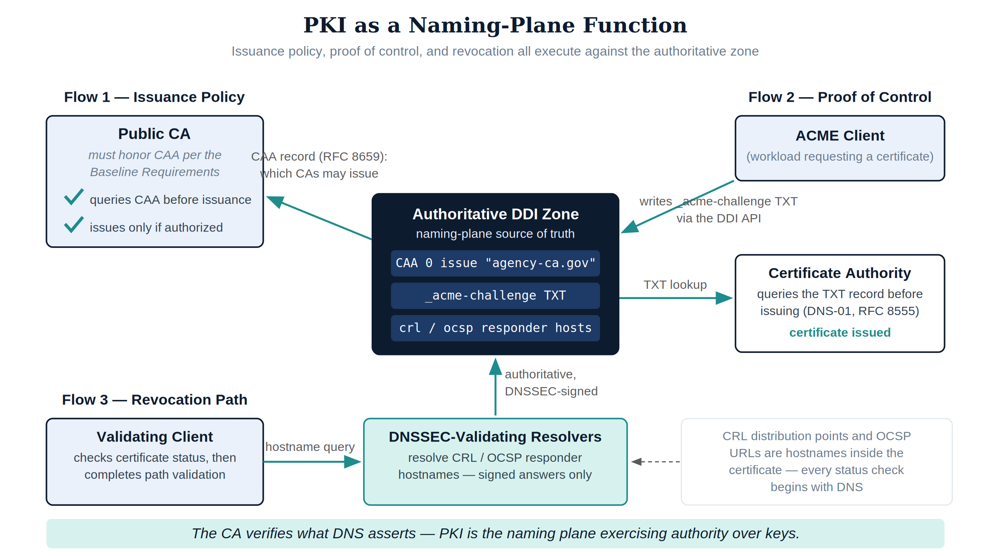
Figure 2: Certificate issuance, policy, and revocation as functions of the authoritative DNS zone

3.2 One Substrate, Three Consumers
This framing is not aesthetic — it dictates ownership of function. Because issuance authorization (CAA), issuance proof (DNS-01), and validation reachability (CRL/OCSP resolution) all execute against the authoritative zone, certificate operations belong to the same functional plane as DNS, DHCP, and IPAM. The series has already met the consumers:
Certificate consumers across the series
Consumer | Certificate Function | Series Home
Device identity at the port | Machine certificates enrolled via SCEP at device provisioning, validated by RADIUS/EAP-TLS | Book 02
Workload transport identity | Server and service certificates issued at IP allocation time, revoked atomically at decommission | Book 01
User and application authentication | Certificate-based authentication and token signing keys | This book, applied in Books 07–08
When Book 01 described a workload spin-up that allocates an IP, creates DNS A/PTR records, and enrolls a machine certificate in one automated transaction, that was this doctrine in motion: name, address, and key bound together at birth, revoked together at death. A certificate tracked separately from the naming plane is a certificate whose name can silently stop being true.

3.3 The Internal Trust Hierarchy
Public CAs cover names the public Internet must trust. Everything else — device certificates, internal service listeners, user authentication certificates, token-signing keys — chains to the agency’s internal hierarchy. The design rules are few and non-negotiable:
- An offline root. The root CA signs exactly two things — issuing CA certificates and its own CRL — and spends its life powered off, its key in a hardware security module, exercised only at ceremonies. The root is a trust anchor under SC-17(b); its compromise is unrecoverable short of re-establishing trust on every relying party in the estate, which is why it is never network-reachable.
- Purpose-scoped issuing CAs. Separate issuing CAs (or at minimum separate certificate profiles with disjoint extended key usage) for device identity, server transport, and user authentication. Scoping limits the blast radius of an issuing-CA compromise to one credential class and makes trust-store policy expressible: the RADIUS infrastructure of Book 02 trusts the device-identity chain, not every certificate the agency ever minted.
- Name-constrained issuance. Issuing CAs carry name constraints limiting them to the agency’s namespaces. A constrained CA that is compromised can still only issue for names the constraint permits — the naming plane exerting authority even over a subverted issuer.
- Status infrastructure as production service. CRL distribution points and OCSP responders are highly available, monitored services whose hostnames live in DNSSEC-signed zones. Relying parties additionally maintain local revocation caches — the IA-5(2)(b)(2) requirement — so that a status-infrastructure outage degrades to cached answers rather than to authentication failure or, worse, to silently skipped checking.
The internal trust hierarchy — key protection descends as lifetime shortens
Tier | Key Protection | Network Posture | Signs | Lifetime Order
Root CA | HSM, offline | Never connected | Issuing CA certificates, root CRL | Decades
Issuing CAs | HSM, online | Enrollment protocols only (ACME/SCEP/EST) | End-entity certificates, CRLs, OCSP responses | Years
End entities | TPM / platform key store / smart card | N/A | Authentication and transport exchanges | Days to months
Closure Necessity — SC-17 certificate issuance under policy. SC-17 requires certificates to be issued under an organization-defined certificate policy and requires trust stores to contain only approved trust anchors. A written certificate policy constrains no one at the moment of issuance; the only machine-enforced expression of issuance policy is the CAA record in the authoritative zone, checked by protocol at every public issuance, paired with an internal CA whose enrollment gates (SCEP/EST/ACME) execute against the same authoritative naming plane. There is no scanner, memo, or procurement clause that prevents an unauthorized issuance after the fact — only the naming plane can refuse it before the fact.

4. Certificate Lifecycle Automation — The End of the Spreadsheet CA

4.1 The Failure Mode Being Retired
The legacy operating model for federal certificate management is a spreadsheet: a list of certificates, expiry dates, owning contacts, and renewal reminders maintained by hand. Its failure modes are so uniform they are practically a curriculum:
- The expiry outage. A certificate expires because the reminder went to a departed employee’s mailbox. The application fails closed at 2 a.m. The post-incident action item is a better spreadsheet.
- The unknown certificate. A scan finds a certificate on a production listener that appears in no inventory. Nobody knows which CA issued it, who holds the private key, or what breaks if it is revoked. It is left alone, which is the worst available answer.
- The immortal key. A service has presented the same key pair for six years across three re-issuances because renewal reused the CSR. Key compromise anywhere in that window is compromise everywhere in it.
These are not staffing failures. They are the arithmetic of manual custody at machine scale: an estate of thousands of certificates with lifetimes measured in weeks cannot be operated by calendar reminders even in principle.

4.2 The Arithmetic Just Got Worse — Deliberately
The CA/Browser Forum has adopted a schedule that reduces the maximum validity of publicly trusted TLS certificates from 398 days stepwise down to 47 days by 2029, with the first reductions already in force in 2026. The browser ecosystem is doing this on purpose: short-lived certificates shrink the window in which a mis-issued or compromised certificate is useful, and they reduce the load-bearing role of revocation (a 30-day certificate is “revoked” by simply not renewing it). The policy consequence for agencies is blunt:
At 47-day lifetimes, manual certificate management is not risky — it is impossible. An estate of 2,000 certificates renewing every 47 days generates a renewal event roughly every 34 minutes, around the clock. No ticket queue processes that. Automation is not a maturity milestone; it is the only arithmetic that closes.

4.3 The Automation Stack
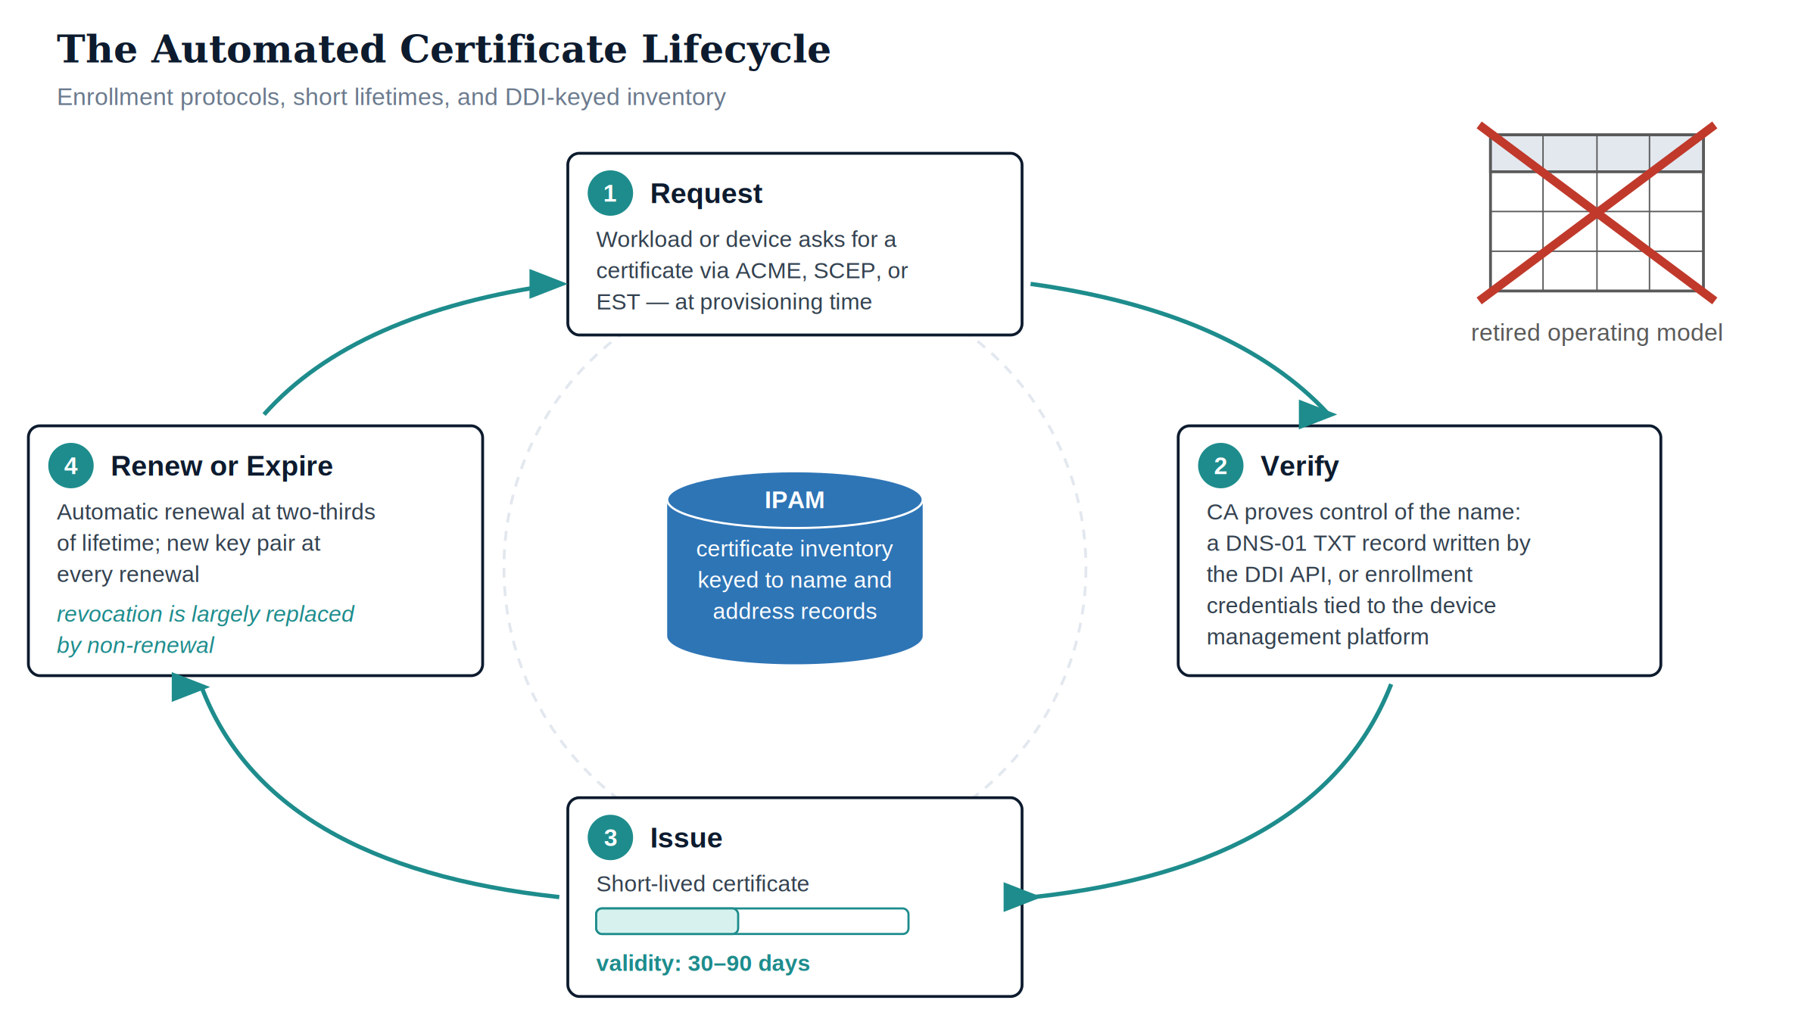
Figure 3: The automated certificate lifecycle: enrollment protocols, short lifetimes, and DDI-keyed inventory
The replacement stack has three layers, all already procured by an agency that built Books 01–02:
- Enrollment protocols. ACME (RFC 8555) for anything that can complete an HTTP-01 or DNS-01 challenge; SCEP or EST for managed devices enrolled through the device management platform (the Book 02 pipeline); platform-native issuance for cloud workloads. In every case the credential arrives at provisioning time, without a human in the loop.
Protocol | Proof of Entitlement | Primary Consumers | Naming-Plane Dependency
ACME (RFC 8555) | DNS-01 TXT record or HTTP-01 token at the name being certified | Web listeners, load-balanced services, anything with a resolvable name | The DDI API writes the challenge record; the authoritative zone is the gate
SCEP | Enrollment challenge delivered through the device management channel | Managed endpoints, network devices (the Book 02 machine certificates) | Device record and certificate bound to the IPAM inventory object
EST (RFC 7030) | TLS-authenticated enrollment, including re-enrollment on an existing certificate | Infrastructure and IoT/OT devices requiring certificate-authenticated renewal | Same inventory binding; renewal authenticated by the expiring credential
Platform-native issuance | Cloud control-plane attestation of the workload | Managed identities, platform-issued transport certificates | Name and identity issued in the same provisioning transaction
- : Enrollment protocols and their naming-plane dependencies {.striped .hover}
- Short lifetimes as policy. Internal CA profiles align with where the public ecosystem is going: lifetimes in days to low months, renewal at two-thirds of lifetime, new key pair at every renewal. Short lifetimes convert revocation from an emergency procedure into a default behavior — the certificate that is not renewed is the certificate that is revoked.
- Inventory as a DDI attribute. Every certificate is recorded against the IPAM object for the name and address it serves — issuer, serial, expiry, enrollment protocol, and the automation that renews it. The certificate inventory is not a new system; it is a column set on the authoritative inventory that CM-8 already requires. An unknown certificate becomes a detectable condition: a listener presenting a certificate with no corresponding IPAM record is, by definition, drift.

4.4 Revocation in a Short-Lived World
Short lifetimes change what revocation is for. With multi-year certificates, revocation carries the entire burden of undoing a bad issuance or a compromised key — and it carries it badly: CRLs grow monotonically, OCSP adds a per-connection dependency, and many clients soft-fail when status infrastructure is unreachable, which converts the revocation check into a formality an on-path attacker can suppress. The modern division of labor:
- Expiry does the routine work. A 30-day certificate that stops renewing is functionally revoked within days, with no status query involved. The overwhelming majority of “revocations” — decommissioned services, role changes, superseded keys — become non-renewals executed by the same automation that issued the credential.
- Revocation does the emergency work. Confirmed key compromise still triggers actual revocation, published to CRL/OCSP immediately, and the compensating actions that matter more at short lifetimes: the automation re-keys and re-issues the affected identity in minutes, and the old certificate ages out shortly regardless.
- OCSP stapling inverts the reachability dependency. Where supported, the certificate presenter fetches and staples its own time-stamped status proof, so the relying party validates status without its own network fetch — removing the soft-fail window and the resolver dependency from the client side of the exchange.
- Local revocation caches are the control-text backstop. IA-5(2)(b)(2)’s required local cache of revocation data means a status-infrastructure outage degrades gracefully instead of silently disabling checking.

4.5 Certificate Telemetry as Evidence
Every lifecycle event — enrollment, renewal, revocation, failed challenge, expiry-without-renewal — is a structured log record streamed to the evidence plane (the SIEM/XDR architecture of Book 13). Three analytics matter operationally:
- Expiry horizon without renewal automation. Any certificate inside two renewal windows of expiry with no bound renewal job is an incident now, not on expiry day.
- Issuance outside the pipeline. A certificate observed on a listener (via the scanning estate of Book 11) that has no corresponding enrollment record and no IPAM binding is unauthorized issuance or shadow infrastructure — either way, a finding.
- Challenge-failure clustering. Repeated DNS-01 failures against one zone indicate either DDI API breakage (an availability problem) or an attempt to obtain certificates for names the requester does not control (a security problem). The same signal, triaged by source.
 Tip
The operational tell that this is working: certificate expiry disappears as an incident category, and certificate questions become DNS queries. “What is presenting on this name, issued by whom, expiring when?” is answered by the naming plane in one lookup — because issuance was never allowed to happen anywhere else.

5. Token-Based Identity — OAuth 2.0, OIDC, and Phishing-Resistant MFA

5.1 The Token Inverts the Trust Model
Session-based authentication asks the network to vouch for continuity: the service trusts that the connection it authenticated is the connection still talking. Token-based authentication asks mathematics to vouch for the claim itself. An OAuth 2.0 / OpenID Connect token is a signed assertion — this user, this device posture, these authorizations, this time window, this signature — that any service can verify offline against the issuer’s published signing keys. As Book 05 states: Kerberos assumes client and server are in the same room; tokens assume they are strangers on the Internet.
The properties that follow are exactly the ones the multipath analysis demanded:
- Path independence. The token is valid on any path, across any number of path switches, through any NAT. Nothing about its validity references the network.
- Verification without callback. The service validates a signature; it does not open a connection to a domain controller. The sub-5 ms location binding is gone.
- Policy at issuance. Every token issuance is a policy decision point: the identity provider evaluates user credential strength, device compliance (the Book 02 machine identity, surfaced as a device claim), location plausibility, and session risk before signing. Conditional access is the policy-enforcement plane consuming identity-plane truth — the plane separation the series hierarchy requires.
- Audit at the token level. Every issuance, refresh, and revocation is a structured event. This is the telemetry NTLM structurally cannot produce and that the evidence plane (Book 13, Book 19) requires.

5.2 The Anatomy of the Token Layer
“Token” names three artifacts with different jobs, lifetimes, and theft values. Conflating them produces bad policy; separating them makes the policy write itself:
The three token artifacts and their theft economics
Artifact | Asserts | Presented To | Lifetime Posture | If Stolen
ID token (OIDC) | Who authenticated, how, and when — the authentication event itself | The requesting application, once | Minutes; consumed at sign-in | Low direct value; not an access credential
Access token (OAuth 2.0) | What the bearer may do against one resource, for a bounded window | The resource (API, database, service) on every call | Short — typically around an hour, shorter for sensitive scopes | Usable until expiry; the reason lifetimes stay short and scopes stay narrow
Refresh token | The right to obtain new access tokens without re-authentication | Only the identity provider | Long-lived but revocable, bound to the client and evaluated against policy at every redemption | The high-value target; every redemption re-enters the policy gate, so revocation and risk signals cut it off
Two engineering consequences follow. First, the policy gate runs more than once: refresh-token redemption re-evaluates conditional access, so a device that falls out of compliance or a user whose risk score spikes loses access at the next refresh — continuous access evaluation tightens this further by pushing revocation events to resources between refreshes. Second, token signing keys are SC-12 objects: the identity provider’s signing keys, published for verification and rotated on schedule, are cryptographic keys whose generation, rotation, and retirement follow the same lifecycle discipline as every certificate in this book. Relying services fetch current keys from the issuer’s published metadata; key rotation is invisible to applications because verification was built against the published set, not against a hardcoded key — the same “automation, not custody” doctrine, applied to the trust fabric itself.

5.3 Certificate-Based Authentication and Phishing-Resistant MFA
Tokens answer how identity travels. The credential ceremony underneath them — how the human proves presence to the identity provider — is where federal policy has drawn its sharpest line. OMB M-22-09 requires phishing-resistant MFA for agency staff, contractors, and partners; BOD 25-01’s secure configuration baselines for the federal cloud productivity estate enforce modern authentication and the retirement of legacy protocols that bypass it.
“Phishing-resistant” is a protocol property, not a marketing adjective. It means verifier-impersonation resistance: the credential cannot be replayed to the identity provider by a look-alike site, because the authentication is cryptographically bound to the origin or channel it terminates in. Exactly two credential families in general federal deployment have this property:
Credential families and verifier-impersonation resistance
Credential | Mechanism | Why It Cannot Be Phished
PIV / smart card (certificate-based authentication) | Private key on hardware token; authentication is a signature over a challenge bound to the TLS channel | The key never leaves the card; a proxied challenge fails channel binding; there is no shared secret to capture
FIDO2 / WebAuthn platform or roaming authenticator | Origin-bound key pair per relying party; the browser signs the actual origin into the assertion | A credential registered to the legitimate origin produces an assertion a look-alike origin cannot use; the phishing site receives a signature for the wrong name
One-time passcodes, push approval, SMS | Shared secret or human approval relayed out of band | Not phishing-resistant — the human can be induced to relay the secret or approve the attacker’s session; excluded by M-22-09 for this reason
Note what both phishing-resistant rows have in common: they are certificates and key pairs. Certificate-based authentication is PKI applied to the user; WebAuthn is PKI with per-origin key issuance. The naming-plane doctrine of this book does not stop at TLS listeners — the human credential layer is the same cryptography, bound to names (origins, principals) the same way.
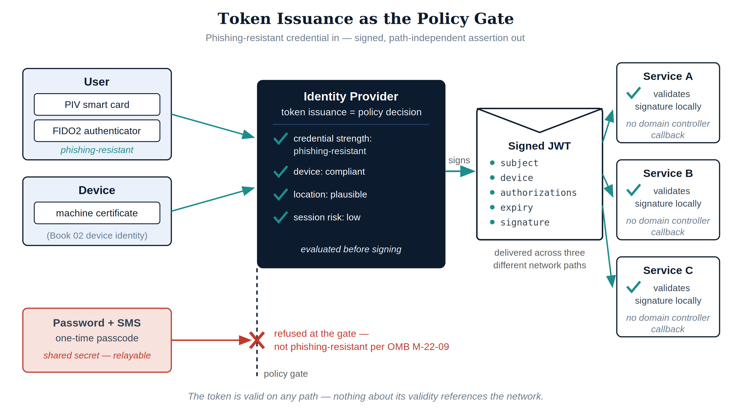
Figure 4: Token issuance as the policy gate: phishing-resistant credential in, signed path-independent assertion out

5.4 Token Theft Is the New Credential Theft — and It Is a Smaller Problem
Moving identity into tokens does not end credential attacks; it relocates them. An attacker who cannot phish a FIDO2 assertion will attempt to steal the token — from process memory, from a compromised endpoint, from an intercepted session. Honest accounting requires stating both halves:
- The exposure is real. A bearer token is usable by whoever bears it. Stolen access tokens work until expiry; stolen refresh tokens work until revoked or rejected by policy.
- The exposure is structurally smaller than what it replaced. A stolen password is durable, reusable everywhere it was reused, and invisible in use. A stolen access token is scoped to one resource, dead within the hour, and every use is a logged, attributable event. A stolen refresh token must survive the policy gate at every redemption — device compliance claims it cannot fake (the Book 02 machine identity surfacing as a token claim), location and risk evaluation, and revocation that takes effect at the next redemption rather than at the next password reset campaign.
- The countermeasures are the rest of this series. Endpoint protection and posture (Books 02, 10) shrink the theft surface; token-level telemetry (Book 13) makes anomalous use detectable — a token minted to one device presenting from another is a high-fidelity signal that password architectures could never emit; proof-of-possession binding, where supported, ties the token to a key the bearer must hold, converting the bearer artifact back into a cryptographic one.
The correct summary is not “tokens cannot be stolen.” It is: the token architecture bounds what theft buys — in scope, in time, and in silence — and each bound is a protocol property, not a promise.
The dependency that makes this a series, not a shopping list: the token asserts authorizations; the authorizations must be true. Book 05’s Principle 1 — restore a single source of truth — is a precondition, not a preference: an identity provider signing group memberships inherited from twelve drifted regional directory trees produces well-formed tokens asserting broken facts. Cryptography transports truth; it does not manufacture it.

6. Federal Policy Alignment
The architecture in this book is not one option among several for satisfying the identity mandates — the mandates were written assuming it. The mapping, directive by directive:
Directive-to-mechanism mapping for the cryptographic identity layer
Directive / Framework | What It Requires | What in This Book Satisfies It
OMB M-22-09 (Federal Zero Trust Strategy) | Phishing-resistant MFA for agency staff, contractors, and partners; enterprise identity systems; per-request authorization | PIV/CBA and FIDO2 as the enforced credential families; token issuance as the per-request policy gate
CISA BOD 25-01 (Implementing Secure Practices for Cloud Services) | SCuBA secure configuration baselines for the federal cloud productivity estate, including modern authentication and retirement of legacy protocols | Phase 3’s legacy-authentication shutdown; token-based authentication as the only remaining path through the identity provider
NIST SP 800-207 (Zero Trust Architecture) | Access decided per-session by policy, using identity, device, and context signals; no implicit trust from network location | Tokens as the per-session decision artifact; device certificates (Book 02) surfaced as claims; location removed from the trust calculus entirely
NIST SP 800-63 (Digital Identity Guidelines) | Authenticator assurance levels; verifier-impersonation resistance at the highest assurance level | Hardware-held, origin/channel-bound key pairs — the only authenticator class that satisfies verifier-impersonation resistance
CISA Zero Trust Maturity Model v2.0 — Identity pillar | Advanced/Optimal maturity requires phishing-resistant MFA and continuous validation with automated identity lifecycle | The full stack of this book: automated credential lifecycle, phishing-resistant enforcement, continuous access evaluation
FedRAMP 20x (Consolidated Rules, 2026) | Continuous, machine-readable KSI evidence rather than periodic assessment | Every issuance, renewal, token grant, and policy evaluation is a structured event; the identity plane’s evidence stream binds to slot-01 (see KSI alignment below)

 Note
Reading the table honestly — none of these directives names a product, and this book names products only as examples of functions. What the directives do name are protocol properties: phishing resistance, per-session decisions, machine-readable evidence, elimination of implicit network trust. Protocol properties are exactly what cannot be procured as adjectives; they exist where the mechanism exists. That is why this table maps each requirement to a mechanism rather than to a purchase.

7. Machine and Workload Identity

7.1 The Non-Human Majority
In a modernized federal environment, human authentications are a rounding error. Every application-to-database connection, every pipeline deployment, every API call between services, every scheduled job authenticates — and historically, each did so with the worst credential in the estate: a service account password, stored in a connection string, rotated never, known to an unknowable set of people and scripts. The workload identity progression retires this in three steps, each removing a class of stored secret:
The workload identity progression — each step removes a class of stored secret
Generation | Credential | What Still Exists to Steal | Residual Failure Mode
Service account | Password in configuration | The password, everywhere the configuration goes | Pass-the-hash, credential sprawl, rotation outages
Service principal with secret or certificate | Client secret or certificate held by the application | The secret/key material, in the application’s custody | Leaked secrets in code repositories; expiry outages
Managed identity | Platform-issued token; no credential in application custody | Nothing in the application; the platform attests the workload | Compromise requires compromising the workload itself — which is the irreducible case
Workload identity federation | External workload exchanges its own platform’s OIDC token for access; no secret crosses the boundary | Nothing stored on either side | Trust misconfiguration — governed as policy, not as secret custody

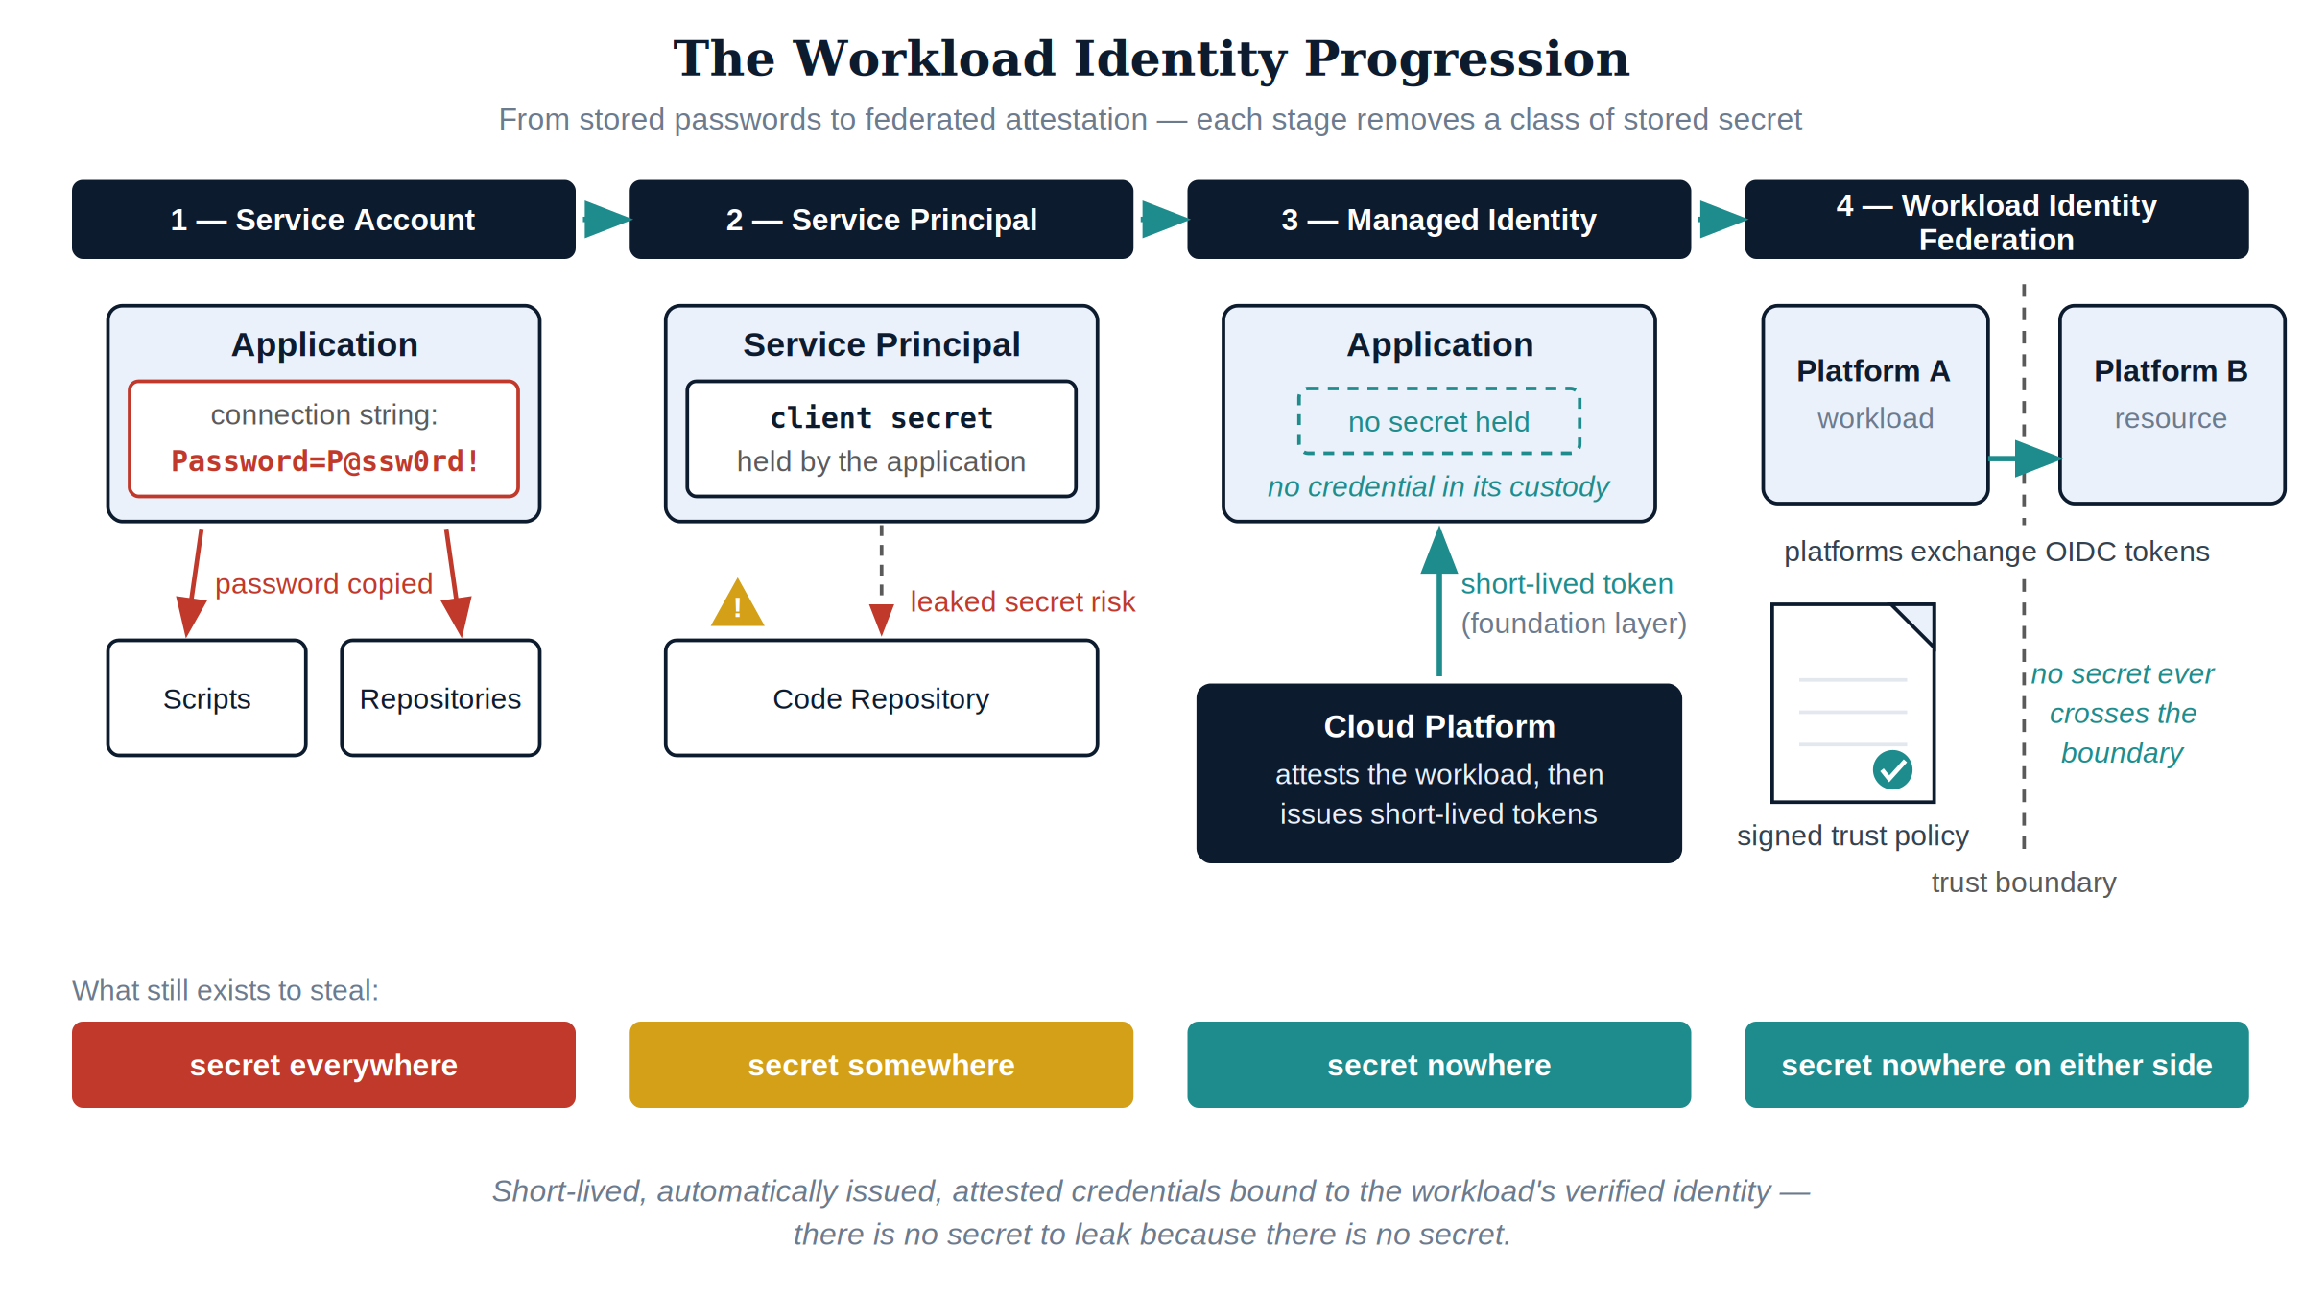
Figure 5: The workload identity progression from stored passwords to federated attestation
The direction of travel is the same one the SPIFFE model formalizes for platform-agnostic environments: short-lived, automatically issued, attested credentials bound to a workload’s verified identity rather than to a stored secret. Whether the implementation is a cloud platform’s managed identity, federation between platforms’ token issuers, or a SPIFFE-style identity document, the doctrine is identical — the workload’s identity is attested by the platform that runs it, at runtime, and expires in minutes. There is no secret to leak because there is no secret.

7.2 Where Keys Live
The workload progression works only if private keys are held somewhere theft-resistant. The storage hierarchy is a policy decision made once and enforced by enrollment profiles — the certificate template or identity platform simply refuses to issue to software-held keys where hardware exists:
Key storage descends in ceremony as lifetime descends in duration
Key Class | Storage | Non-Exportability | Applies To
Trust anchors, issuing CA keys, token-signing keys | HSM (FIPS 140-validated) | Hardware-enforced; keys are used, never read | The trust fabric itself
Device and user credentials | TPM / smart card / platform authenticator | Hardware-enforced; attestation available at enrollment | Book 02 machine certificates, PIV, FIDO2
Workload transport and application keys | Platform key service / managed key vault | Platform-enforced; access is an audited API call under its own policy | Service certificates, application secrets in transition
Ephemeral session and federation keys | Memory, minutes-scale lifetime | Lifetime is the control | Token exchange, TLS session keys
The pattern repeats the trust-hierarchy rule from the PKI section: the longer a key lives and the more it signs, the deeper in hardware it sits. Enrollment-time attestation — the platform proving the key was generated in hardware before the CA issues against it — turns this from an aspiration into an issuance gate, which is IA-5(2)(a)(1)’s “enforce authorized access to the corresponding private key” implemented as protocol rather than as procedure.

7.3 What This Sets Up
This is the hinge to the application books. Book 07 replaces domain credentials in the SQL Server estate with managed identities and token-based authentication; Book 08 is its implementation runbook. Read them as applications of this chapter — the database is simply the first large estate where the workload-identity progression is executed end-to-end:
Books 07–08 as applications of this book’s doctrine
Books 07–08 Mechanism | The Book 03 Doctrine It Applies
Domain credential replaced by a platform-attested identity on each database host | The workload identity progression, stage three: secret nowhere
Connection strings stripped of passwords; the application requests a token at connect time | Token-based identity: the proof travels in the credential, verified without a callback to a domain controller
NTLM eliminated by removing Kerberos’s reason to fall back, not by blocking a port | “The Fallback Nobody Chose”: fallback ends when the session-based protocol is no longer in the path at all
Every database authentication becomes a policy-gated, logged token issuance | Token issuance as the policy decision point; audit at the token level
Migration sequenced by estate inventory and dependency mapping before any login is disabled | Phase 1’s rule: establish truth before demanding it
Later parts repeat the same move against other estates — privileged sessions (Book 10), data-plane access (Book 12), detection surfaces (Book 13) — and none of them introduces new identity doctrine, because after this part there is none left to introduce.

8. Phased Implementation
The sequencing principle: establish truth before demanding it. Each phase creates the inventory and telemetry that make the next phase’s enforcement decisions safe. Durations are indicative for a mid-size federal estate; the ordering is not optional, because each phase’s gate is the previous phase’s output.

8.1 Phase 1 — Certificate Estate Discovery (Weeks 1–4)
Enumerate before automating. Network scanning of every listener, CA database exports from every issuing authority (including the departmental ones nobody admits to), trust-store audits on representative endpoint and server populations, and correlation of all of it against the IPAM inventory. The outputs: a certificate inventory keyed to DDI records, a list of unknown-issuer certificates for investigation, and a trust-anchor census against which SC-17(b) cleanup is scoped. In parallel, enable authentication-protocol auditing across the estate — the Kerberos/NTLM fallback measurement that Book 07 requires begins here.
Gate: every production certificate has an owner, an issuer, and an IPAM binding — or an investigation ticket.

8.2 Phase 2 — Issuance Automation (Weeks 5–12)
Stand up (or rationalize) the internal hierarchy: offline root ceremony, purpose-scoped issuing CAs on HSMs, CAA records published in every public zone, ACME service wired to the DDI API for DNS-01, SCEP/EST confirmed against the Book 02 device pipeline. New issuance flows through automation from this phase forward; existing certificates migrate at their next renewal rather than by forced re-issuance. Shorten internal lifetimes profile by profile as renewal automation proves itself.
Gate: zero manual issuance requests for covered certificate classes in a 30-day window; renewal automation demonstrated through at least one full cycle.

8.3 Phase 3 — Token Migration and Phishing-Resistant Enforcement (Weeks 13–24)
Register applications against the identity provider; enforce phishing-resistant authenticators for privileged accounts first (IA-2(1)), then for the general population (IA-2(2)); disable legacy authentication protocols tenant-wide per the BOD 25-01 baseline posture — the step that converts MFA from a setting into a fact, because a protocol that bypasses the policy gate is a bypass of every policy the gate enforces. Report-only conditional access precedes enforcement at each step, using the token telemetry to find the applications that would break before they break.
Gate: legacy authentication blocked with a measured zero business impact; privileged access impossible without a phishing-resistant assertion.

8.4 Phase 4 — Workload Identity Conversion (Weeks 25–40)
Execute the progression of the workload identity table against the service estate: inventory every stored secret (connection strings, pipeline variables, configuration files), convert platform-resident workloads to managed identities, establish federation for cross-platform workloads, and expire the vacated secrets rather than merely abandoning them. Book 08 is the worked example of this phase for the database estate; its runbook structure generalizes.
Gate: the secret inventory trends monotonically to zero for covered workload classes, and every remaining entry has a named exception with an expiry date.

9. NIST SP 800-53 Rev 5 Control Closure
The table maps each control this document closes to its state without the architecture, its state with it, and — per the series’ Closure Necessity doctrine — why no alternate mechanism closes it. Control language follows NIST SP 800-53 Rev 5.
NIST SP 800-53 Rev 5 control closure for Part 3 — Certificates & Tokens
Control | Title | Without This Architecture | With This Architecture | Why No Alternative Closes It
IA-5(2) | Authenticator Management — Public Key-Based Authentication | Certificates are validated inconsistently or not at all; revocation status is unchecked because CRL/OCSP endpoints are unreachable or unknown; private keys accumulate in files and spreadsheets with no access enforcement; certificate identities are not reliably mapped to accounts | Path validation to approved trust anchors with status checking on every authentication; private keys generated and held in hardware (TPM, HSM, smart card) with enforced access; certificate-to-account mapping maintained in the directory; local revocation caches per IA-5(2)(b)(2) preserve validation when the network path to revocation data fails | Rev 5 IA-5(2) requires constructing and verifying a certification path including status information at authentication time — a per-authentication protocol act. No manual process, periodic audit, or scanner can perform path validation for a live authentication; only validating infrastructure wired into the authentication flow can, and its revocation endpoints resolve through the authoritative naming plane
SC-12 | Cryptographic Key Establishment and Management | Keys are generated ad hoc by whoever needs them, distributed by file copy, stored in configuration, never destroyed; key custody is undocumentable because it was never a system property | Keys are generated in platform key services and hardware modules at provisioning time, distributed only as protocol artifacts (never as files), stored in non-exportable hardware where the platform supports it, and destroyed by lifecycle automation at decommission — the same atomic transaction that retires the name and address | SC-12 governs generation, distribution, storage, access, and destruction as managed properties. At workload scale (thousands of keys, lifetimes in days) these properties can only hold if the key lifecycle is executed by the provisioning platform itself; human custody cannot demonstrate destruction or constrain distribution of material it handles by hand
SC-17 | Public Key Infrastructure Certificates | Certificates issued by any CA a project happens to use, under no enforced policy; trust stores accumulate unapproved anchors that no process reviews | All issuance flows through policy-gated enrollment (ACME/SCEP/EST) against the authoritative naming plane; CAA records make public issuance policy protocol-enforced; trust stores are configuration-managed to contain only approved anchors, with drift detected against the DDI-keyed certificate inventory | SC-17 requires issuance under a certificate policy and trust stores containing only approved trust anchors. A policy document cannot refuse an issuance; only issuance-time gates can — CAA checked by protocol at every public issuance, enrollment authentication at every internal issuance. Trust-anchor governance requires an authoritative inventory to diff against; no scanner creates one
IA-2(1) | Identification and Authentication — Multi-Factor Authentication to Privileged Accounts | Privileged access gated by passwords or phishable MFA (OTP, push); a relayed credential yields the estate’s highest privileges | Privileged accounts require phishing-resistant, verifier-impersonation-resistant authenticators (PIV/CBA or FIDO2), enforced at token issuance; no phishing-resistant assertion, no privileged token | The control requires MFA; M-22-09 requires the phishing-resistant form. Phishing resistance is a protocol property — origin/channel binding of a hardware-held key. No training program, detection rule, or policy makes a relayable secret non-relayable; only a credential with nothing to relay does
IA-2(2) | Identification and Authentication — Multi-Factor Authentication to Non-Privileged Accounts | Standard users authenticate with passwords plus phishable second factors; phishing any user yields a foothold that lateral movement converts into privilege | All user access requires MFA with phishing-resistant authenticators as the enforced default; legacy authentication protocols that bypass MFA are disabled per the BOD 25-01 baseline posture | Same mechanism as IA-2(1); additionally, MFA enforcement is real only if unenforceable paths are closed — legacy protocols that skip the token-issuance policy gate must be disabled at the identity provider, because a control bypassed by protocol selection is not a control
Closure Necessity — IA-5(2) revocation checking. Rev 5 IA-5(2)(b)(1) requires validating certificates “by constructing and verifying a certification path to an accepted trust anchor, including checking certificate status information.” Status checking is a network act against CRL/OCSP endpoints whose addresses resolve through DNS — which makes authoritative, DNSSEC-protected resolution a precondition of every PKI authentication in the estate. No alternative exists: a spreadsheet cannot answer a status query, an annual audit cannot check status at authentication time, and an unvalidated resolver turns the revocation check itself into a spoofing target. The naming plane of Book 01 is not adjacent to this control; it is inside it.
Closure Necessity — SC-12 at machine scale. SC-12 makes key generation, distribution, storage, access, and destruction managed properties of the system. Short-lived certificates and workload identities multiply key events by orders of magnitude — an estate that once rotated hundreds of keys annually now cycles thousands weekly. The only mechanism that satisfies the control’s five verbs at that rate is lifecycle automation executed by the provisioning platform, with keys born in hardware and destroyed in the decommission transaction. There is no staffing level at which manual key custody closes SC-12 for a machine-scale estate; the arithmetic, not the ambition, is the constraint.
Closure Necessity — IA-2(1)/(2) phishing resistance. The MFA controls close only with authenticators that are impossible to relay, not merely inconvenient to phish. Verifier-impersonation resistance is a cryptographic property — a private key that never leaves hardware, signing a challenge bound to the origin or channel it terminates in. Any credential a human can read, forward, or approve can be extracted by deceiving the human; no awareness campaign changes that. The only closure path is a credential with no relayable secret — which is to say, the certificate and key-pair infrastructure this book builds. Phishing-resistant MFA is PKI wearing a usability layer.
 Note
FedRAMP 20x KSI Alignment — slot-01 identity
In the series’ continuous-monitoring architecture, this book’s evidence binds to the slot-01 identity evidence slot, which carries the KSI-IAM theme rules in the evaluation engine. Slot-01 was previously fed by the identity-plane and privileged-access parts of the original series; under the 19-part restructure it additionally binds this book’s certificate-lifecycle and token-issuance evidence — enrollment and renewal logs from the automated CA pipeline, token issuance and conditional-access evaluation records, and the authenticator-strength posture for privileged and non-privileged accounts.
Per the series’ conformance-tooling doctrine (Theme E): the ScuBA-based configuration rules attest that identity settings match the baseline. They measure drift from an intended state — they cannot author one. The intended state — which CA may issue for which names, which authenticators count as phishing-resistant, which workloads hold which identities — is authored by the architecture in this book, and the slot-01 evidence stream is what makes that authored state continuously attestable. The authoritative KSI Closure Necessity Matrix lives in Book 00; Book 19 carries the evidence procedures behind it.

10. Series Context — Part 3 of 19
This part completes the foundation trilogy:
- Book 01 — the naming and addressing plane: authoritative DNS, DHCP, IPAM, and the landing zone that makes every workload enumerable.
- Book 02 — device identity at the port: the machine certificate as the admission credential, quarantine as the default.
- Book 03 (this document) — cryptographic identity as a whole: certificates as naming-plane artifacts, lifecycle automation as the only sustainable operating model, tokens as the path-independent carrier of user and workload identity.
Everything after this point is application and evidence. Book 05 and Book 06 modernize the transport that made this identity model mandatory. Books 07–08 execute this book’s doctrine against the database estate — the first proof that session-bound authentication can be removed, not merely deprecated. The privileged access, detection, and continuity parts consume the token-level telemetry this architecture emits, and Book 19 assembles it into the authorization package.

10.1 How the Series Doctrine Lands in This Part
For readers tracking the five doctrine themes across the series:
The five doctrine themes as they appear in Part 3
Theme | Its Expression in This Book
A — Closure Necessity | IA-5(2), SC-12, SC-17, IA-2(1)/(2) each closed with a named mechanism that admits no alternative — path validation as a protocol act, key lifecycle as provisioning-platform behavior, CAA as protocol-enforced issuance policy, verifier-impersonation resistance as a cryptographic property
B — DIA Fixes Nothing | The transport half of this book’s premise: the modern path is faster and carries no identity; the pipe cannot vouch for anyone. Identity had to move into the credential because the network stopped carrying it
C — The ADC/Proxy Dissolution | The session-terminating middleboxes that broke Kerberos across the 2010s dissolve into planes that verify signatures instead of holding state; TLS termination points become certificate consumers of the automated lifecycle, not session anchors
D — Functional Planes, Not Divisions | Certificates and tokens are identity-plane truth; conditional access and ZTNA are enforcement-plane consumers. Issuance authority lives in the naming plane. No owner is named anywhere in this book, because none needs to be
E — Conformance Tooling Coverage Gap | Configuration baselines attest that identity settings match an intended state; this book authors the intended state. The slot-01 evidence stream is what makes the authored state continuously attestable
The doctrine in one paragraph: names are authoritative (Book 01), devices prove themselves with keys bound to names (Book 02), and every identity — human, device, workload — is a cryptographic claim about a name, issued under policy the naming plane enforces, carried in a credential no network path can break (Book 03). The network stopped being a place. After this part, identity no longer cares.

Federal Application-Aware Networking — Part 3 of 19. Parts 1–2 established the naming plane and device identity; Part 3 establishes cryptographic identity for users, devices, and workloads; Part 4 anchors those identities in the authoritative HR and organizational source of truth. Parts 5–19 apply this foundation to transport, applications, operations, and the authorization package.

